**Test Management**

UNIT-III

**INTRODUCTION:**

* Test management is the art of planning and directing a test assignment to success.
* In many ways like project management, and yet not quite the same.
* Test management must be done in close cooperation with project management,
* sometimes by the same person,
* Sometimes by different people.
* The test manager is the link between the test team and the development team

**Business Value of Testing :**

1. Purpose of Testing
2. Testing business case
   * The Value of Product Improvement
   * The Value of Decision Improvement
   * The Value of Process Improvement
3. On the face of it, testing adds no value.
4. The product under testing
5. is—in principle—not changed after the test has been executed.

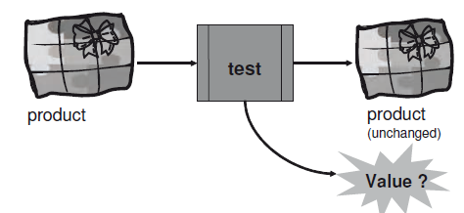

* *The business value of testing lies in the savings that the organization can achieve from improvements based on the information the testing provides.*
* Improvements can be obtained in three places:
  + The product under development
  + The decisions to be made about the product
  + The processes used in both testing and development
* Sometimes be difficult to understand and express what the value is
* Test managers know and understand the value of testing
* Test managers communicate to other project participants, and to higher management.

**Purpose of Testing:**

* *Purpose of testing is getting information about the product under testing.*
* Testing is the intelligence office of the company
* The places we gather our raw data from are the test logs and the incident reports
* A few examples of such information are:
  + Number of passed test cases
  + Coverage of the performed test
  + Number and types of failures
  + Defects corrected over time
  + Root causes of the failures
* Most of this information is “invisible” or indigestible unless we testers make it available in appropriate formats

**The Testing Business Case:**

* A well-established way to express the value of testing for the product is based on the cost of quality.
* This can be expressed as value of product improvement:

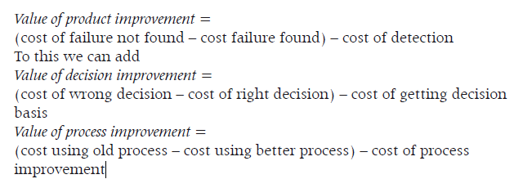

* A value may be expressed either uantitatively or qualitatively.
* Quantitative values can be expressed in actual numbers—euros, pounds, or dollars or numbers of something,
* Qualitative values cannot be calculated
* like that, but may be expressed in other terms or “felt.”

**The Value of Product Improvement:**

* The value of product improvement is the easiest to assess.
* One goal of all development is reliability in the products we deliver to the customers.
* Reliability is the probability that software will not cause the failure of a system for a specified time under specified conditions.
* A product’s reliability is measured by the probability that faults materialize in the product when it is in use.

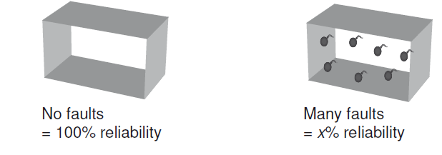

* The less failures that remain in the product we release, the higher is the reliability of the product and the lower the risk of the product
* The earlier we get a defect removed the cheaper it is.
* Reviews find defects and dynamic testing finds failures, and this enables the correction of the underlying defects.
* The cost of the defect correction depends on when the defect is found.
* If the defect remains in the product and is not found until encountered as a failure in dynamic test, it costs 100 units to correct it.
* The failures found during development and testing are called internal failures, and they are relatively cheap.
* If the customer gets a failure in production—an external failure
* The basic reason for this raise in cost is that defects in software do not go away if left unattended; they multiply
* *To get the full value of the test, it should start as early as possible in the course of a development project, preferably on day 1*

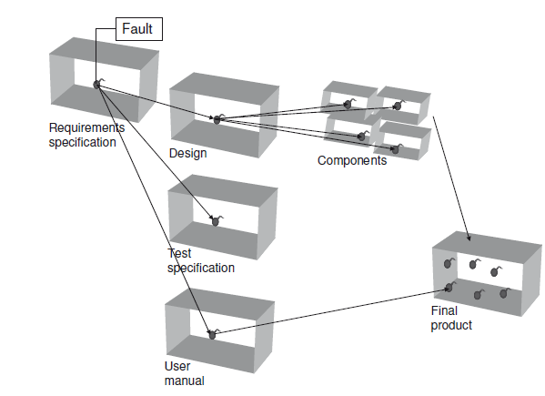 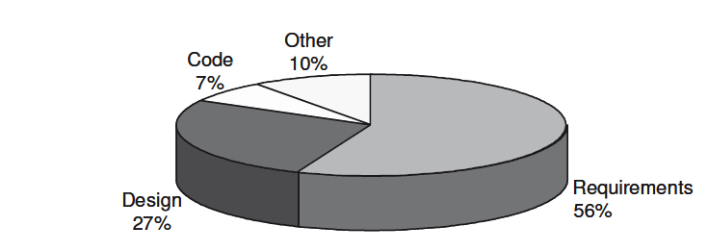

**The Value of Decision Improvement:**

* The point of view of decision making such as decisions concerning release (or not) of a product the confidence in the product and quality of the decisions are proportional to the quality and the amount of the information provided by testing
* As testing progresses, more and more information is gathered and this enhances the basis for the decisions.
* The more knowledge the decision makers have about
  + Parts of the product have been tested
  + Depth coverage of test
  + Detected defects have been removed
  + Still remaining
* The quality of the testing reflects in the quality of the information it provides.
* Good testing provides trustworthy information and poor testing leave us in ignorance
* If the starting point is a good product, a good test will provide information to give us confidence that the quality is good.
* If the starting point is a poor product, a good test will reveal that the quality is low.
* A test report with documentation of the test and the test results can be used to prove that we fulfilled contractual obligations

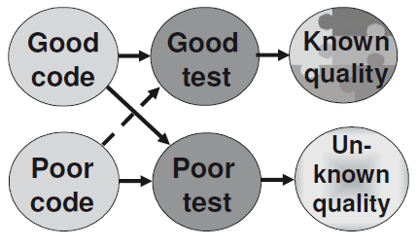

**The Value of Process Improvement:**

* *The process improvement point of view the information gained from testing* is invaluable in the analysis of how well processes fit and serve the organization.
* The results of such analysis can be used to identify the process that could be the subject for process improvement.
* The process to improve may be both the testing process and other processes.
* When the testing process improves, the number of failures sent out to the customers falls.
* The organization’s reputation for delivering quality products will rise.

**Test Management Documentation:**

* **Overview**
* **Higher Management Documentation**
  + Test Policy
  + Test Strategy
* **Project Level Test Management Documentation**
  + Master Test Plan
  + Level Test Plan
  + Test Plan Template
  + Scheduling Test Planning
  + Test Report
* Proper test management requires that information about the decisions that test management makes is available and comprehensive to all stakeholders.
* Decisions are normally captured in a number of documents.
* The test management documentation comprises:
  + Test policy
  + Test strategy
  + Project test plan
  + Level test plan
* The **test policy** holds the organization’s philosophy toward software testing.
* The **test strategy** is based on the policy. It can have the scope of an organizational unit or a program It contains the generic requirements for the test for the defined scope.
* A **master test plan** is for a particular project. It makes the strategy operational and defines the test levels to be performed and the testing within those levels.
* A **level test plan** is for a particular test level in a particular project. It provides the details for performing testing within a level.

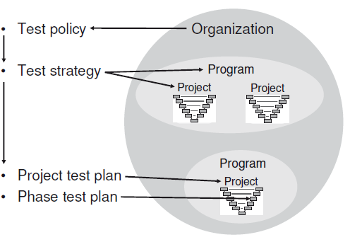

* The presentation of this documentation depends on the organization’s needs, general standards, size, and maturity.
* It can also vary from all the information being presented together
  + In one document, or even as part of a bigger document, to it being split into a number of individual documents

**Higher Management Documentation:**

* Higher management, that is management above project managers and test managers, is responsible for the two types of test management documentation.
* The documentation is used by everybody in the organization involved in testing.

**Test Policy:**

* The test policy defines the organization’s philosophy toward software testing.
* It is the basis for all the test work in the organization.
* A policy must be behavior-regulating in the good way—*it is like a lighthouse for all the testing activties*
* The test policy defines the organization’s philosophy toward software testing.
* It is the basis for all the test work in the organization
* The test policy must be short and to the point.
* It is the responsibility of the top management to formulate the policy
* The test policy must include:
  + 1. Definition of testing
  + 2. The testing process to use
  + 3. Evaluation of testing
  + 4. Quality targets
  + 5. Approach to test process improvement
* The test policy applies to all testing. The policy must cover all test targets.
* This means that there must be a policy for:
  + » Testing new products
  + » Change-related testing
  + » Maintenance testing
* *Test Policy; Definition of Testing*
* The definition of testing is a brief statement formulating the overall purpose of the test in the organization.
* *Test Policy; The Testing Process*
* The testing process is an overview of the activities to be performed or a reference to a full description of the testing process.
* *Test Policy; Evaluation of Testing*
* The evaluation of testing is the measurement to be made in order for the quality of the testing to be determined.
* *Test Policy; Quality Targets*
* The quality targets to be achieved should be expressed so that the measurements can be used to see if we reach the goals.
* *Test Policy; Approach to Test Process Improvement*

**Test Strategy:**

* The test strategy is high-level, and it should be short.
* It should also be readily available to all with a stake in the testing within the scope of the strategy.
* The strategy could be issued in a document, but it would be a good idea to present it in table form on a poster or on the intranet in the organization.
* The overall test strategy may be chosen among the following possible approaches to the testing:
  + Analytical—Using for example a risk analysis as the basis
  + Model-based—Using for example statistical models for usage
  + Consultative—Using technology guidance or domain experts
  + Methodical—Using for example checklists or experience
  + Heuristic—Using exploratory techniques
  + Standard-compliant—Using given standards or processes
  + Regression-averse—Using automation and reuse of scripts
* A test strategy for a defined scope could contain the following information:
* Test strategy identifier
  + 1. Introduction
  + 2. Standards to use
  + 3. Risks to be addressed
  + 4. Levels of testing and their relationships
  + For each level, as appropriate
  + 4.1 Entry criteria
  + 4.2 Exit criteria
  + 4.3 Degree of independence
  + 4.4 Techniques to use
  + 4.5 Extent of reuse
  + 4.6 Environments
  + 4.7 Automation
  + 4.8 Measurements
  + 4.9 Confirmation and regression testing
  + 5. Incident management
  + 6. Configuration management of testware
  + 7. Test process improvement activities
* *The strategy identifier is the configuration management identification information*
* for the strategy itself. It could be formed by the:
* » Name of the strategy
* » Organizational affiliation
* » Version
* » Status

***1.*Strategy-Introduction*:***

* + - Purpose of the document
    - Scope of the strategy
    - References to other plans, standards, contracts, and so forth
    - Readers' guide

***2.*Strategy-Standards to Be Complied With:**

* + Standards may be both external to the organization and proprietary standards.
  + *Standards are very useful. Many people with a lot of experience have contributed t*o standards.

***3.*Strategy- Risks:**

* + The basis for the strategy can be the product risks to mitigate by the testing. Appropriate project risks may also be taken into consideration**.**

***4.*Strategy-Test Levels and Their Relationships**

**description of the test levels:**

The levels can for example be:

1. Component testing
2. Component integration testing
3. System testing
4. System integration testing
5. Acceptance testing

***5.Strategy- Level Entry Criteria:***

* + This is a description of what needs to be in place before the work in the test level can start.
  + The strictness of the entry criteria depends on the risk: The higher the risk the stricter the criteria.

***6.Strategy; Level Exit Criteria:***

* + The testing exit or completion criteria are a specification of what needs to be achieved by the test. It is a guideline for when to stop the testing—for when it is “good enough.”
  + Testing completion criteria represent one of the most important items in a comprehensive test strategy, since they have a great influence on the subsequent testing and the quality of a whole system.
  + Testing completion criteria represent one of the most important items in a comprehensive test strategy, since they have a great influence on the subsequent testing and the quality of a whole system.
  + The test report has been approved by the project manager.

**7.Strategy-Degree of Independence*:***

* The degree of independence increases with the “distance” between the producer and the tester. These degrees of independence in testing have been defined:
  + 1. The producer tests his or her own product
  + 2. Tests are designed by another non tester team member
  + 3. Tests are designed by a tester who is a member of the development team
  + 4. Tests are designed by independent testers in the same organization
  + 5. Tests are designed by organizationally independent testers (consultants)
  + 6. Tests are design by external testers (third-party testing

**8.Strategy-Test Case Design Techniques to Be Used:**

* + The choice of test case design techniques is very much dependent on the risk—high risk: few, comprehensive techniques to choose from; low risk: looser selection criteria

**9.Strategy- Extent of Reuse:**

* + Reuse can be a big money and time saver in an organization.
  + Effective reuse requires a certain degree of maturity in the organization.
  + Configuration management needs to be working well in order to keep track of items that can be reused.

**10.Strategy- Environment in Which the Test Will Be Executed:**

* + Generic requirements for the test environment must be given here.
  + The specific environment must be described in the test plan, based on what the strategy states

**11.Strategy-Approach to Test Automation:**

* + This is an area where the strategy needs to be rather precise in order for tool investments not to get out of hand.
  + Technical people, testers—love tools. Tools are very useful and can ease a lot of tedious work.

**12.Strategy-Measures to Be Captured:**

* + Measures are also necessary to be able to monitor and control the progress of the testing.
  + We need to know how the correspondence is between the reality and the plan.
  + We also need to know if and when our completion criteria
  + have been met.

**13.Strategy- Approach to Confirmation Testing and Regression Testing:**

* + Confirmation testing is done after fault correction to confirm that the fault has indeed been removed.
  + Regression testing should be done whenever something has changed in the product

**14.Strategy-Approach to Incident Management:**

* + The configurations management system is sufficient here
  + It must be described how incidents are to be reported and who the incident reports should be sent to for further handling.

**15.Strategy-Approach to Configuration Management of Testware*:***

* + Configuration management of testware is important for the reliability of the test results
  + A good configuration management system will also help prevent extra work in finding or possibly remaking testware that has gone missing— something that happens all too often in testing

**16.Process Strategy- Approach to Test Improvement:**

* + This could be a refinement of the approach described in the policy

**Project Level Test Management Documentation:**

The two types of test management documentation discussed in this section belong to a particular project.

* The *master test plan* should be produced by the person responsible for testing on the project, ideally a test manager.
* The *level test plans* should be produced by the stakeholder(s) carrying the appropriate responsibility.

**Master Test Plan:**

* The master test plan documents the implementation of the overall test strategy for a particular project.
* The master test plan must be closely connected to the overall project plan, especially concerning the schedule and the budget.
* The master test plan has many stakeholders and missions, and it must at least provide the information indicated in the following list to the main stakeholders

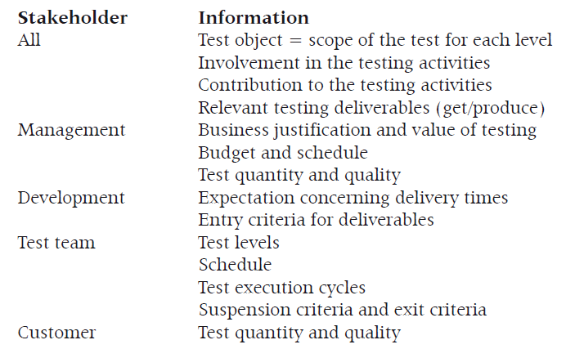

**Level Test Plan:**

* A level test plan documents a detailed approach to a specific test level, for example a component test or acceptance test.
* The level test plan describes the implementation of the master test plan for the specific level in even more precise detail.
* The size of a level test plan depends on the level it covers—a component test plan for single components may be just 5–10 lines; system test plans may be several pages.

**Test Plan Template:**

* The structure of the test plans, both the master test plan and any level test plans, should be tailored to the organization’s needs.
* A template could be based on the IEEE 829 standard. This standard suggests the following contents of a test plan:

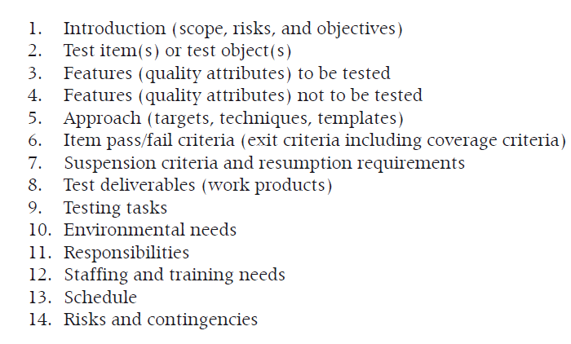

* *The test plan identifier is the configuration management identification information*
* for the test plan itself. It could be formed by the
* » Name of the plan
* » Organizational affiliation
* » Version
* » Status

**Scheduling Test Planning:**

* Planning is important and planning takes time
* It is important to plan activities rather than just jump headfirst into action.
* The work on the planning provides a deeper understanding of the task at hand you have written down or sketched out on a piece of paper.
* Because planning takes time and because it is important, it should be planned so that it can start as early as possible
* The benefits of starting test planning early are many:
  + » There is time to do a proper job of planning.
  + » There is more time to talk and/or negotiate with stakeholders.
  + » Potential problems might be spotted in time to warn all the relevant
  + stakeholders.
  + » It is possible to influence the overall project plan.
* When you plan you have to keep in mind that a plan needs to be SMART:
  + Specific—Make it clear what the scope is
  + Measurable—Make it possible to determine if the plan still holds at any time
  + Accepted—Make every stakeholder agree to his or her involvement
  + Relevant—Make references to additional information; don’t copy it
  + Time-specific—Provide dates
* The test plan should be reviewed and approved by all stakeholders to ensure their commitment

**Test Report**:

* The purpose of test reporting is to summarize the results and provide evaluations based on these results.
* A test report should be issued at the completion of each test level and the end of the entire testing assignment task
* According to IEEE 829 the test report should contain:
* Test report identifier
  1. Summary
  2. Variances
  3. Comprehensiveness assessment
  4. Summary of results
  5. Evaluation
  6. Summary of activities

**Test Estimation:**

* General Estimation Principles
* Test Estimation Principles
* The Estimation Process
* Estimation Techniques
  + Estimation; Best Guess (FIA)
  + Estimation; Analogies and Experts
  + Estimation; Delphi Technique
  + Estimation; Three-Point Estimation
  + Estimation; Function Points
  + Estimation; Test Points
  + Estimation; Percentage Distribution
* From Estimations to Plan and Back Again
* Get Your Own Measurements

**General Estimation Principles:**

* Estimation is a prediction of how much time it takes to perform an activity.
* It is an approximate calculation or judgment.
* An estimate is typically based on the professional understanding of experienced practitioners.
* Estimation is input to the scheduling. Only in that activity will we transform the estimated hours into dates.
* Estimates are predictions about the future and predictions are by definition uncertain.
* You should always calculate with an uncertainty in every estimate and document this uncertainty with the estimate

**Test Estimation Principles:**

* Estimating test activities is in many ways like all other estimation in a project.
* We need to take all tasks, even the smallest and seemingly insignificant, into account.
* The time to complete must be estimated for each task defined in the task section, including all the test process activities from test planning to checking for completion.
* The test estimation is different from other project estimations, because the number of failures is not known in advance
* The estimation must include:
  + Time to produce incident registrations
  + Possible time to wait for fault analysis
  + Possible time to wait for fault correction
  + Time for retest and regression test (minimum three iterations!)

**The Estimation Process:**

* You should of course use your organization’s standard process for estimation, if there is one.
* estimation procedure like the generic one described here.
* Define the purpose of the estimation—Is this estimation the first approach, for a proposal, or for detailed planning?
* 2. Plan the estimating task—Estimation is not a two-minute task; set
* sufficient time aside for it.
* 3. Write down the basis for the estimation—Here the scope and the size of the work are determined, and all factors that may influence
* the estimates are registered. This includes factors related to the
* nature of the processes we are working by, the nature of the project
* we are working in, the people we are working with, and any risks
* we are facing.
* 4. Break down the work—This is the work breakdown (i.e., the listing
* of all the tasks to estimate). Do this as well as possible in relation to
* the purpose.
* 5. Estimate—Use more than one technique as appropriate.
* 6. Compare with reality and reestimate—This is the ongoing monitoring

and control of how the work that we have estimated is actually going.

**Estimation Techniques:**

* The following estimation techniques are the most used and an expression of the best practice within estimation.
  + » FIA (finger in the air) or best guess
  + » Experience-based estimation
  + » Analogies and experts
  + » Delphi technique
  + » Three-point estimation (successive calculation)
  + » Model-based estimation
  + » Function points
  + » Test points
  + » Percentage distribution

**Estimation-Best Guess (FIA):**

* This technique is more or less pure guesswork, but it will always be based on some sort of experience and a number of (unconscious) assumptions.
* The uncertainty contingency is probably around 200%–400% for estimates based on best guess.

**Estimation; Analogies and Experts:**

* a testing project that is comparable to the one we are estimating, we might use that as a baseline to do our estimation.
* Analogies may also be based on metrics collected from previous tests.
* We may estimate the number of iterations of the test based on recent records of comparable test efforts.
* We can calculate the average effort required per test on a previous test effort and multiply.
* Experts, in the estimation context, know what they are talking about and have relevant knowledge

**Estimation; Delphi Technique:**

* This is a simple technique even in complex situations.
* You must appoint an estimation group as appropriate.
* This can be stakeholders and/or experts in the tasks to estimate.
* The steps in this estimation process are:
  + Each member of the group gives an estimate.
  + The group is informed about the average and distribution of the estimates.
  + Those giving estimates in the lower quartile and in the upper
  + quartile are asked to tell the rest of the group why their estimates
  + were as they were.
  + » The group estimates again—this time taking the previous result and the provided arguments for the “extreme” estimates into account.
  + » This may continue two, three, four, or more times until the variation in the estimates is sufficiently small.

**Estimation; Three-Point Estimation:**

* Three-point estimation is a statistical calculation of the probability of finishing within a given time.
* The technique is useful for quantifying uncertainty to the estimate.
* The technique is also called successive calculation because tasks are broken down and the estimates successively calculated until the variance is within acceptable limits.
* Three point estimation is based on three estimates:
  + The most optimistic time (ideal conditions)
  + The most likely time (if we do business as usual)
  + Thea most pessimistic time (Murphy is with us all the way)

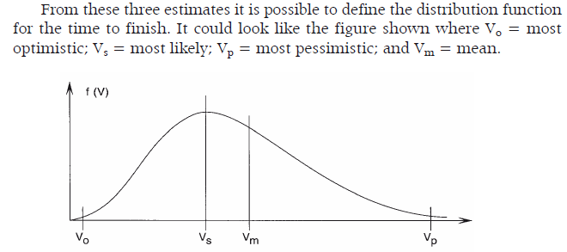

* We can use the approximated formula to derive:
* Vm = (Vo + 3*Vs + Vp) / 5
* S = (Vp – Vo) / 5 (the standard deviation)
* we can calculate the time needed for any probability
* of finishing the task

**Estimation; Function Points:**

* This technique is a factor estimation technique initially published by Albrecht in 1979.
* it now maintained by IFPUG —International Function Points User Group.
* The estimation is based on a model of the product.
* Five aspects of the product are counted from the model:
  + External inputs
  + External outputs
  + External enquiries
  + Internal logical files
  + External interface files
* The counts are then multiplied with a weight and the total of the weighted counts is the unadjusted sum.
* It requires some training to be able to count function points correctly.
* The disadvantage of using function points is that they require detailed requirements in advance

**Estimation; Test Points:**

* In 1999 Martin Pol et al. published a dedicated test estimation technique called test points as part of the TMAP method.
* The technique is based on the function point technique, it provides a unit of measurement for the size of the high-level test
* The technique converts function points into test points based on the impact of specific factors that affect tests, such as:
  + » Quality requirements
  + » The system’s size and complexity
  + » The quality of the test basis (the document(s) the test is specified toward)
  + » The extent to which test tools are used

**Estimation; Percentage Distribution:**

* This technique is a so-called top-down estimation technique.
* Test efforts can be derived from the development effort.
* The estimation using this technique starts from an estimate of the total effort for a project.
* This estimate may be the result of the usage of appropriate
* Estimation techniques at the project management level.
* The next step is to use formulas (usually just percentages) to distribute
* This total effort over defined tasks, including the testing tasks
* The formulas are based on empirical data, and they vary widely from organization to organization.

**Estimation; Percentage Distribution:**

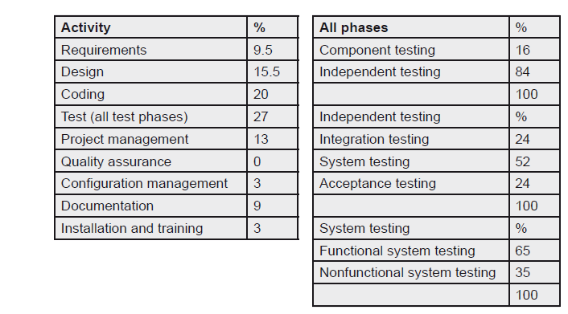

**From Estimations to Plan and Back Again:**

* The estimation is done to provide input to the scheduling activity in the project planning.
* In the scheduling we bring the estimates for the defined testing tasks together with the people, who are going to be performing the tasks.
* Estimations should be in hours.
* The scheduling provides the dates: dates for when the performance of each of the tasks should begin, and dates for when they are expected to be finished.
* When defining the expected finish date for a task we need to take several aspects into account:
  + The start and/or finish dates of others tasks that this task depends
  + on to start, if any
  + The earliest possible start date for the task
  + The general calendar regarding public holidays
  + The pure estimate for the time to finish the task
  + The efficiency of the employee(s) to perform the task—typically 70–
  + 80% for a full time assignment
  + The employee(s)’s availability—this should NOT be less than 25%

**Get Your Own Measurements:**

* All estimates are based on experience—maybe very informally (FIA), maybe very formally (like function points).
* Better estimation means more reliable estimations
* we both, management and customers, want.
* In order to get better estimates we need to collect actual data.
* Empirical data for estimation is part of the measurements we are collecting.
* So we need to chip in to establish a set of simple measurements of
  + time,
  + costs, and
  + size in all project

**Test Progress Monitoring and Control:**

* **Collecting Data**
* **Presenting the Measurements**
  + S-Curves
  + Pie Chart
  + Check Sheets
  + Risk-Based Reporting
  + Statistical Reporting
* **Stay in Control**

**S-Curves:**

* The most used, most loved, and most useful way of presenting progress information and controlling what’s happening is S-curves.
* S-curves can be used for many different metrics
* for example, be:
  + Test cases (run, attempted, passed, completed)
  + Incidents (encountered, fixed, retested)
* S-curves can give us early warnings of something being wrong
* The principle in S-curves is that our work falls in three phases:
  + Phase 1: Slow start—not more than 15–25%
  + Phase 2: Productive phase—55–65%
  + Phase 3: The difficult part—10–25%

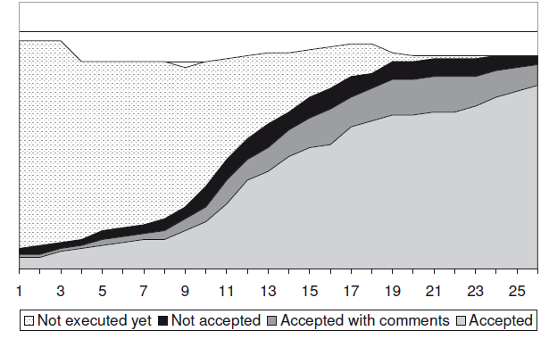

**Pie Chart :**

* Pie charts are used to give an overview of the proportions of different aspects relative to each other.

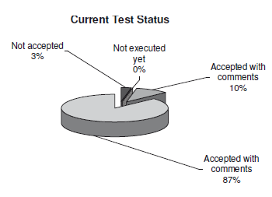

**Check Sheets:**

* Check sheets are a good way to give a quick overview of status. They can be  
  used to show progress compared to plan.
* Check sheets can be presented as colorful graphics or expressed as lists or hierarchies**.**

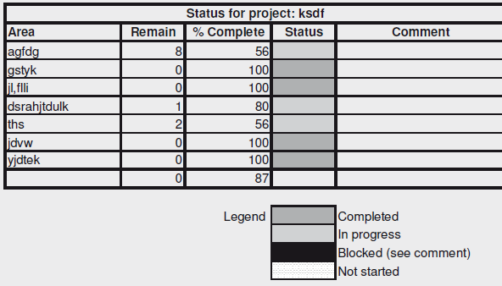 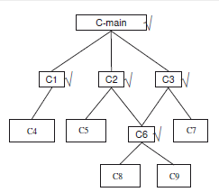

**Risk-Based Reporting:**

* If our test approach is based on identified and analyzed risks it is appropriate to report on the test progress in terms of these risks.
* The purpose of this test is to eliminate the risk,

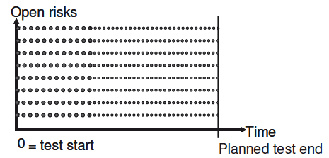

**Statistical Reporting :**

Statistics is the science of patterns in a variable world. We can say that

statistics make the invisible visible.

This means that statistical methods can be used to help us:

» Understand the past

» Control the present

» Predict the future

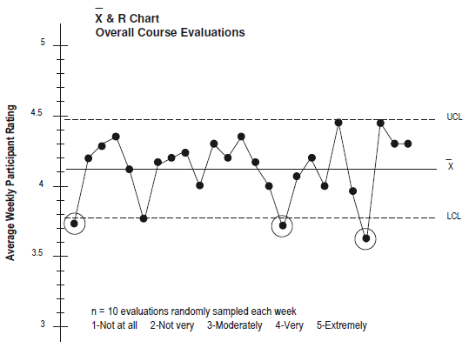

**Stay in Control:**

* Sometimes we need to take action to stay in control.
* Keeping the triangle of test quality in mind, you have three aspects we can change—and you must change at least two at the time.
* The aspects are:
  + The resources for the task
  + The time for the task
  + The quality of the work to be performed
* Usually when things are getting out of control it is because we are behind schedule or because our time frame has been squeezed.
* The important message to the test manager is
* If you do not control the test, it will control you!

**Testing and Risk:**

* **Introduction to Risk-Based Testing**
  + Risk Definition
  + Risk Types
    - *Project Risks*
    - *Product Risks*
  + Testing and Risk Management
* **Risk Management**
  + Risk Identification
  + Lessons Learned and Checklists
  + Risk Workshops
  + Brainstorming
  + Expert Interviews
  + Independent Risk Assessments
* **Risk Analysis**
  + Risk Template
  + Perception of Risks
  + Scales for Risk Analysis
  + Effect
  + Probability
  + Risk Level
* **Risk Mitigation**
  + What to Do to Mitigate Risks
  + How to Mitigate Risks by Testing
  + When to Mitigate Risks by Testing
* The golden rule of testing is:
  + **Always test so that whenever you have to stop you have done the best possible test.**
* *The best possible test depends on the risk associated with having defects left in the product when it is released to the customer*
* it is impossible to test everything. There is a risk involved in all sample control: the risk of overlooking def ects in the areas we are not testing.
* **Risk Definition:** The possibility of realizing an unwanted negative consequence of an incident.
* A risk therefore has two aspects:
  + » Effect (impact—consequence)
  + » Probability (likelihood—frequency)
* The two aspects of risk can be combined in
  + *Risk level = probability x effect*

**Risk Types:**

* Risks are divide them into classes, corresponding to where they may hit, or what they are threatening.
* Risks hit in different places, namely;
* **The business**: The business risks are things threatening the entire company or organization from a “staying-in-business” point of view.
* **The processes:**Process risk threatens the effectiveness and efficiency with which we work on an assignment. Like
  + Missing processes
  + The organization’s lack of knowledge about the processes
  + Inadequate processes
  + Inconsistencies between processes
  + Unsuitable processes
  + Lack of support in the form of templates and techniques
* **The project**: Project risks are related to the project and the successful completion of the project. Risks concerning the project may be originated in:
  + People assigned to the project (e.g., their availability, adequate skills and knowledge, and personalities)
  + Time
  + Money
  + Development and test environment, including tools
  + External interfaces
  + Customer/supplier relationships
* The product: Product risks are related to the final product. Product risks may be originated in:
  + Functional and nonfunctional requirements
  + Missing requirements
  + Ambiguous requirements
  + Misunderstood requirements
  + Requirements on which stakeholders do not agree

**Testing and Risk Management:**

* Testing and management of risks should be tightly interwoven as they support each other.
* Testing can be based on the results of risk analysis, and test results can give valuable feedback to support continuous risk analysis.
* The risk analysis results can also be used to prioritize and distribute the test effort.
* Testing can also mitigate project risks

**Risk Management:**

* Risk management consists of the following activities:
* » **Risk identification**: In risk identification we are finding out what may happen to threaten the process, The identified risks are evaluated in the risk analysis and ordered relatively to each other
* Useful techniques are:
  + Lessons learned
  + Checklists
  + Risk workshops
  + Brainstorms
  + Expert interviews
  + Independent risk assessments
* » Risk mitigation
* » Risk follow-up
* **Risk analysis**: Risk analysis is the study of the identified risks. *The analysis must be performed by all the appropriate stakeholders*
* A **risk template** or a risk register is a very useful tool in risk management
* A risk template should include:
  + - Risk identification (e.g., number or title)
    - Risk description
    - Probability
    - Effect
    - Exposure
    - Test priority
    - Mitigation action = test type
    - Dependencies and assumptions
* **Perception of Risks:** In fact *most risk analysis is based on perceptions; it is usually not possible to determine risk* probability and effect totally objectively.
* The descriptions encompass:
  + - » Project managers
    - » Developers
    - » Testers
    - » End users
* **Scales for Risk Analysis**
  + We can work with two different kinds of scale, namely:
    - » Qualitative
    - » Quantitative
* **Effect:**The effect is the impact or consequences of a risk if (when?) it occurs. *quantitative scale for the effect is the actual cost imparted by* a failure occurring out in the field. The actual cost can be measured in any agreed currency
* Final effect = Σ(effect*weight) / Σ(weight)
* **Probability:** The probability is the likelihood of the materialization of a risk. we first of all need to agree on a scale.
* On a *quantitative scale* probability can be measured on a scale from 0 to 1 or a scale from 0% to 100%.
* **Risk level** : calculated for each of the identified risks as
* Risk level = final effect x final probability
* *The distribution of the final risk level over individual risks is used to plan the test activities.*
* *It can be used to prioritize the test activities and to distribute the* available time and other resources according to the relative risk level.

**Risk Mitigation:**

* We use the results of the risk analysis as the basis for the risk mitigation.
* “To mitigate” means “to make or become milder, less severe or less painful.
* Faced with the list of risks and their individual risk level we have to go through each of the risks and decide:
  + What we are going to do
  + How we are going to do it
  + When we are going to do it